7. RESULTS AND DISCUSSION
Validation of Analytical Method:
- Since the HPLC method has been developed, validation of method using various parameters was performed to ensure that the performance characteristic of the method meets the requirements for the intended analytical application.
The following parameters are to be validated
    - System suitability
    - Specificity
    - Accuracy
    - Linearity
    - Precision
    - Robustness
    - Limit of detection
    - Limit of Quantitation

VALIDATION PARAMETERS:
7.1 . SYSTEM SUITABILITY:
A Standard solution was prepared by using Rosuvastatin and Fenofibrate working standards as per test method and was injected Five times into the HPLC system.
The system suitability parameters were evaluated from standard chromatograms by calculating the % RSD from five replicate injections for Rosuvastatin and Fenofibrate, retention times and peak areas.
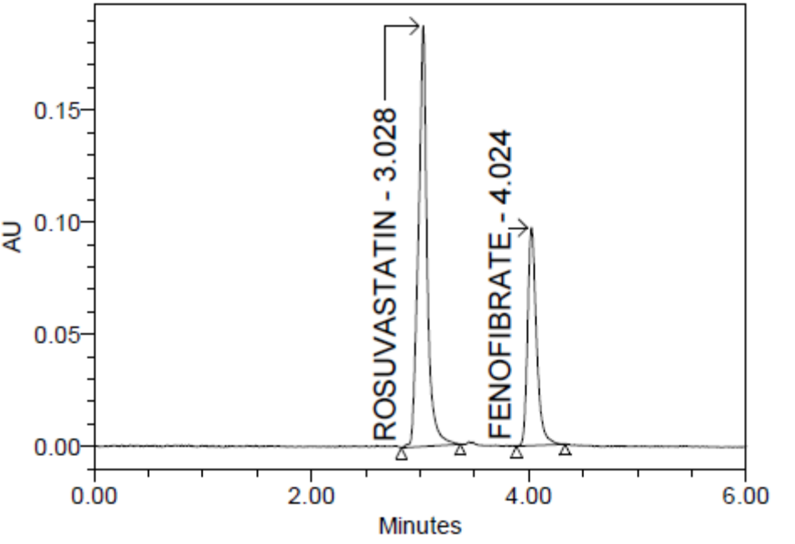
Typical Chromatogram of Standard-2; Injection-1
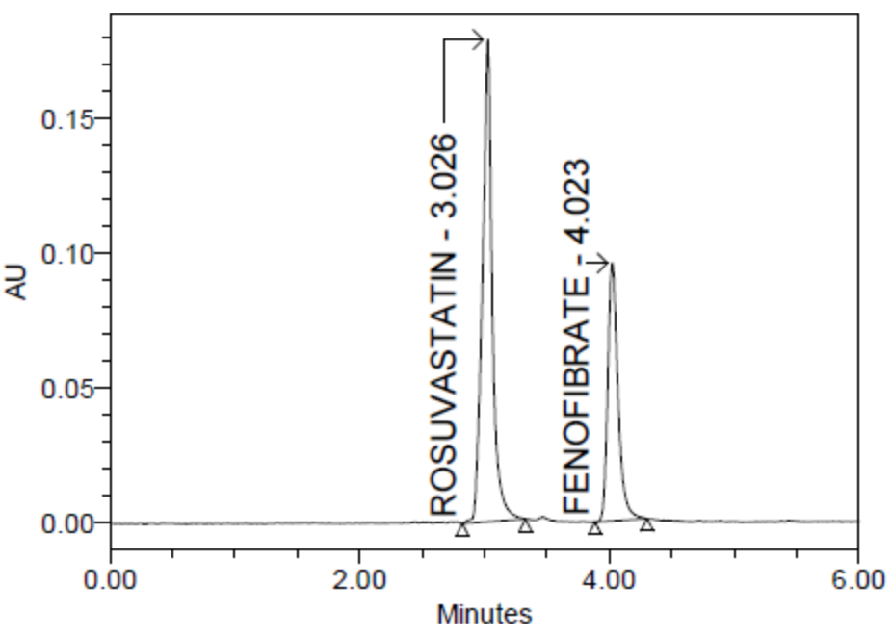
Typical Chromatogram of Standard-2; Injection-2
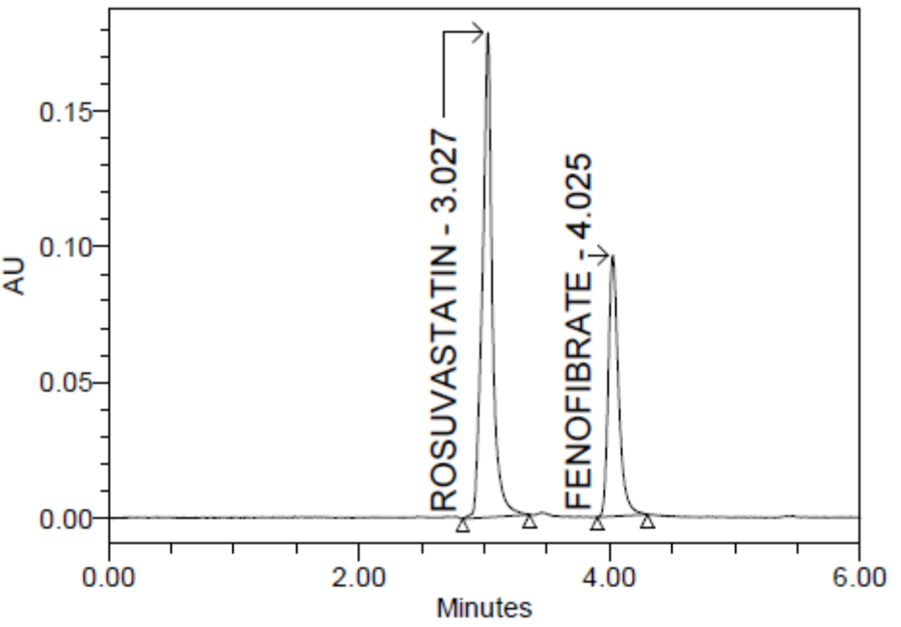
Typical Chromatogram of Standard-2; Injection-3

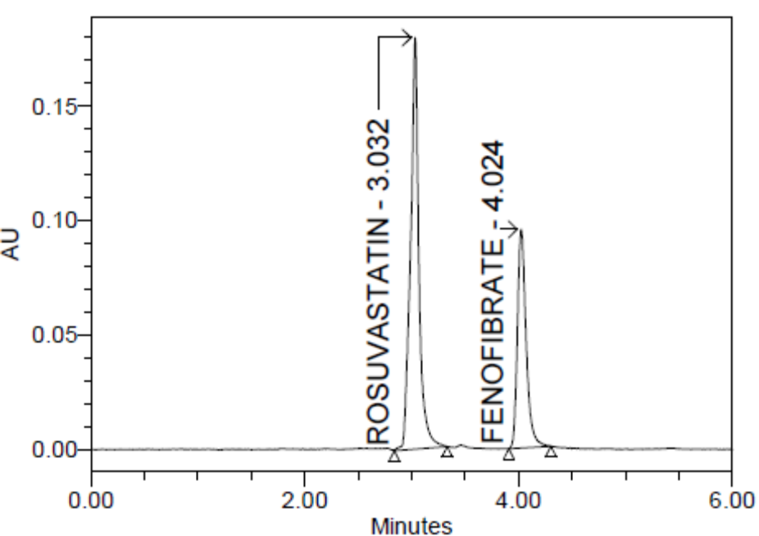
Typical Chromatogram of Standard-2; Injection-4

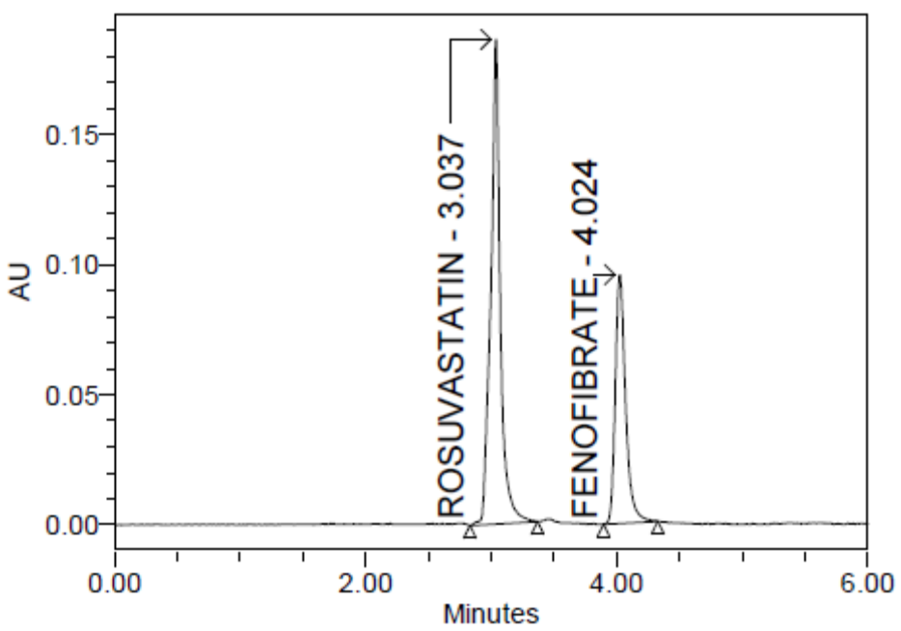
Typical Chromatogram of Standard-2; Injection 5

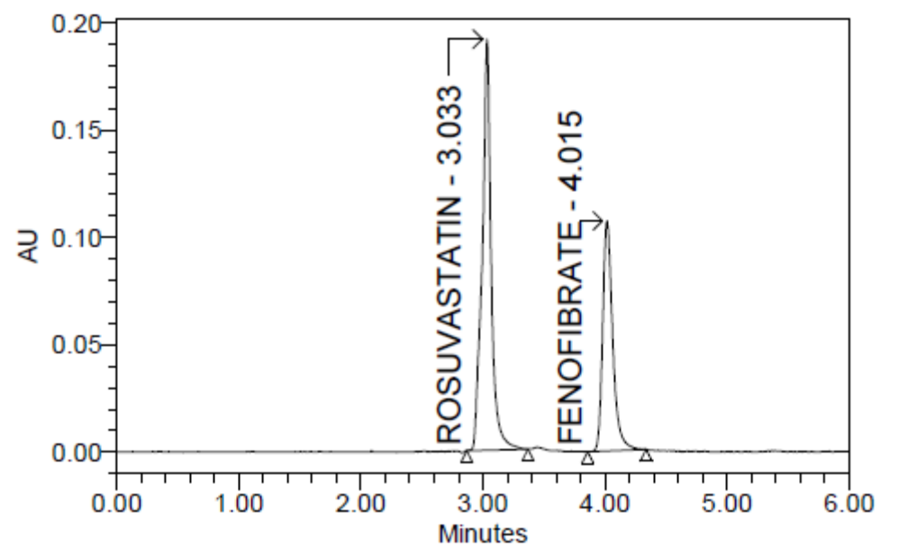
Typical Chromatogram of Sample-1
Fig 12: System suitability chromatography of Rosuvastatin and Fenofibrate
Table 9: System suitability data of Rosuvastatin and Fenofibrate
Parameter | Rosuvastatin | Fenofibrate | Acceptance criteria
Retention time | 3.028 | 4.024 | +-10
Theoretical plates | 6829 | 12565 | >2500
Tailing factor | 1.07 | 1.34 | <2.00
% RSD | 0.4 | 1.0 | <2.00

Standard Results of Rosuvastatin
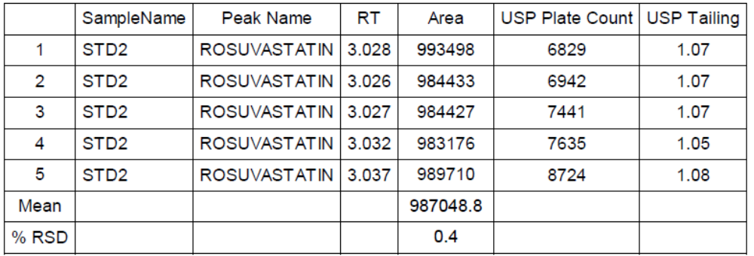
Standard Results of Fenofibrate

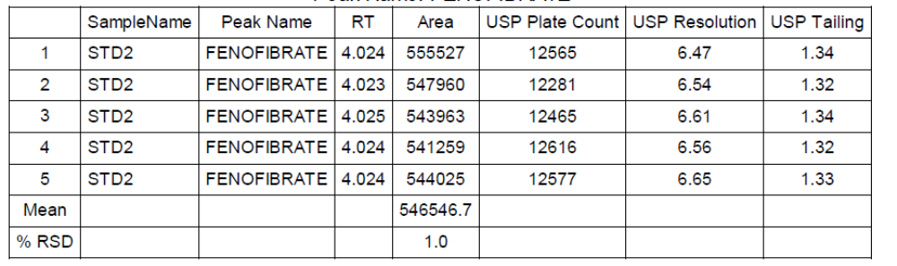
Acceptance criteria:
- Resolution between two drugs must be not less than 2
- Theoretical plates must be not less than 2000
- Tailing factor must be not less than 0.9 and not more than 2.It was found from above data that all the system suitability parameters for developed method were within the limit.

RESULT:
Results of system suitability study are summarized in the above table. Six consecutive injections of the standard solution showed uniform retention time, theoretical plate count, tailing factor and resolution for both the drugs which indicate a good system for analysis.

7.2. SPECIFICITY:
Solutions of standard and sample were prepared as per the test method are injected into chromatographic system. The chromatograms of Standard and Sample were same identical with same retention time.

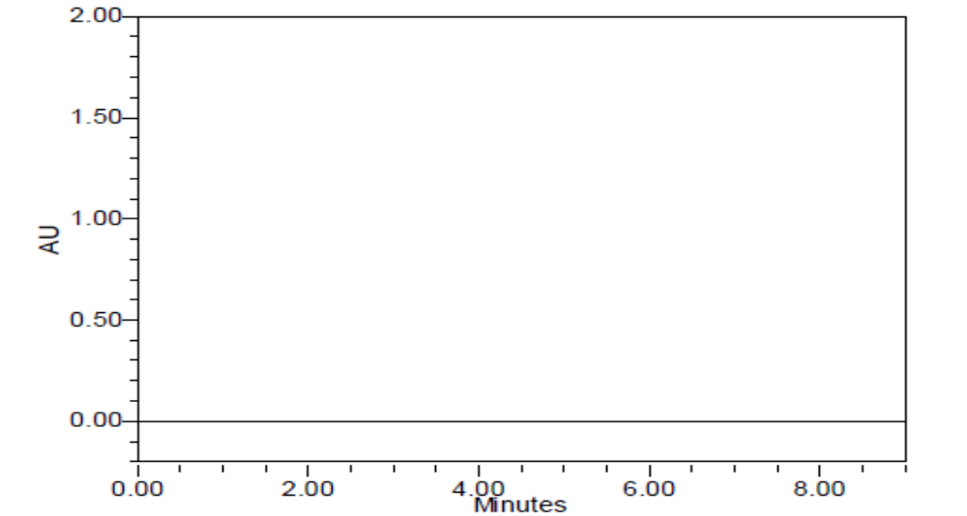

Fig 13: Typical chromatogram of the blank
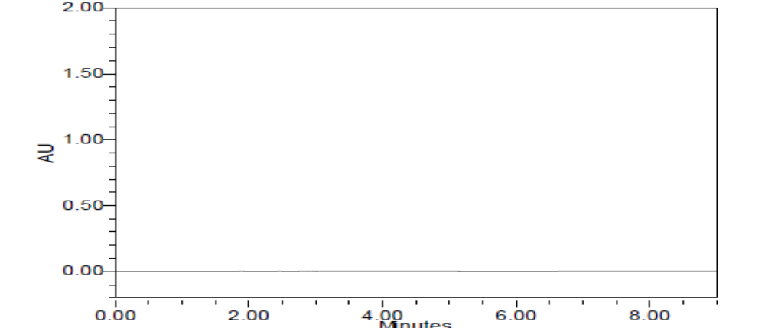
Fig 14: Typical chromatogram of the Placebo
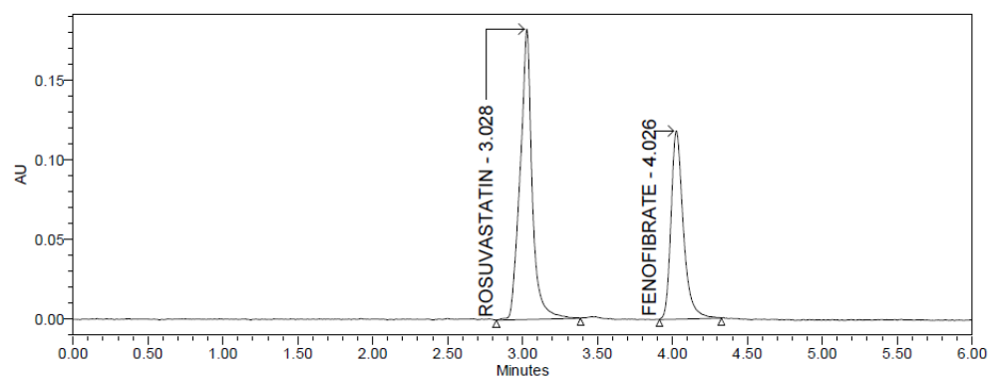
Fig 15: chromatogram representing specificity of standard
Fig 16: chromatogram representing specificity of sample
Table 10: Specificity data for Rosuvastatin and Fenofibrate
S no | Sample name | Rosuvastatin area | Rt | Fenofibrate Area | Rt
1 | Standard | 1019391 | 3.028 | 675802 | 4.026
2 | Sample | 987068 | 3.033 | 542102 | 4.015
3 | Blank | - | - | - | -
4 | Placebo | - | - | - | -

Acceptance criteria:
Chromatogram of standard and sample should be identical with near Retention time.
Blank interference:
A study to establish the interference of blank was conducted. Diluent was injected into HPLC system as per the test procedure.
Acceptance criteria:
Chromatogram of blank should not show any peak at the retention time of analyte peak. There is no interference due to blank at the retention time of analyte. Hence the method is specific.

RESULT:-
The forced degradation study showed the method was highly specific, the chromatographic peak does not interfere with any other impurities. This proves that, excipients have no effect on the analytical method. On the other hand, blank peak did not overlap drug peak. So the method is highly selective.

7.3. ACCURACY:
Preparation of Standard stock solution:
Accurately weigh and transfer 10 mg of Rosuvastatin and Fenofibrate 160mg of working standard into a 100ml clean dry volumetric flask and sonicate to dissolve it completely and make volume up to the mark with the same solvent.
(Stock solution)
Further pipette 1ml of the above stock solutions into a 10ml volumetric flask and dilute up to the mark with diluent.
Preparation Sample solutions:
Preparation sample solution for accuracy 50% solution (With respect to target Assay concentration):
Accurately weigh and transfer 430mg of Rosuvastatin and Fenofibrate into a 100 ml 0f clean dry volumetric flask and sonicate to dissolve it completely and make volume up to the mark with the same solvent.
(Stock Solution).
Further pipette 0.5ml of the above stock solution into a 10ml volumetric flask and dilute up to the mark with diluent.

Preparation sample solution for accuracy 100% solution (With respect to target Assay concentration):
Accurately weigh and transfer 430mg of Rosuvastatin and Fenofibrate into a 100 ml 0f clean dry volumetric flask and sonicate to dissolve it completely and make volume up to the mark with the same solvent.
(Stock Solution).
Further pipette 1ml of the above stock solution into a 10ml volumetric flask and dilute up to the mark with diluent.
Preparation sample solution for accuracy 150% solution (With respect to target Assay concentration):
Accurately weigh and transfer 430mg of Rosuvastatin and Fenofibrate into a 100 ml 0f clean dry volumetric flask and sonicate to dissolve it completely and make volume up to the mark with the same solvent.
(Stock solution).Further pipette 1.5ml of the above stock solution into a 10ml volumetric flask and dilute up to the mark with diluent.
Procedure:
Inject the standard solution, Accuracy -50%, Accuracy -100% and Accuracy -150%
solutions.
Calculate the amount found and amount added for Rosuvastatin and Fenofibrate and calculate the individual recovery and mean recovery values.
Sample solutions at different concentrations (50%, 100%, and 150%) were prepared and the % recovery was calculated.
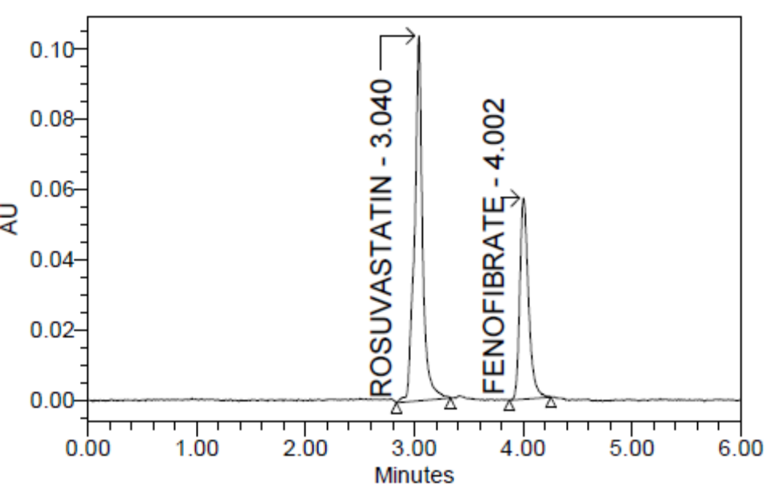
Fig 17: Typical chromatogram for Accuracy 50 %
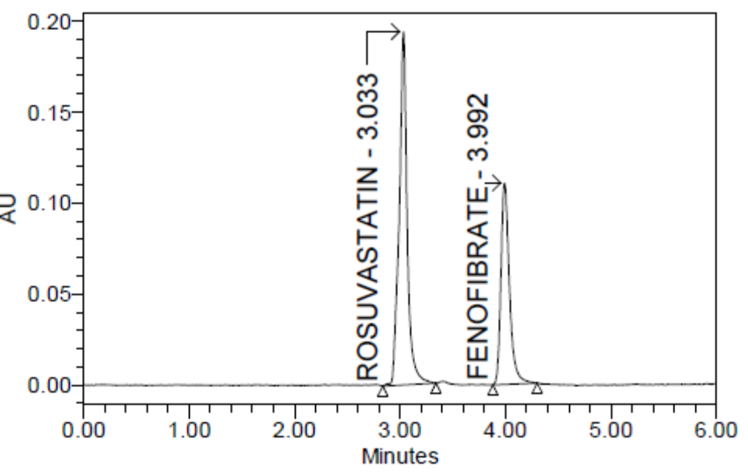
Fig 18: Typical chromatogram for Accuracy 100 %
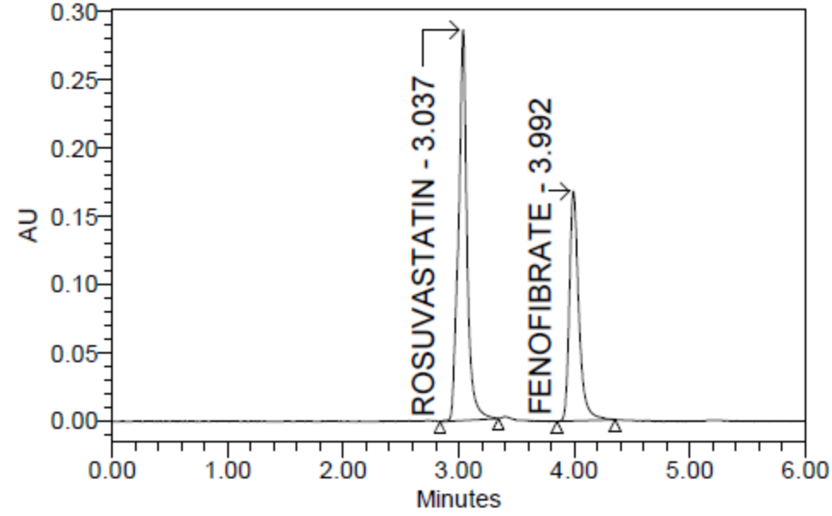
Fig 19: Typical chromatogram for Accuracy 150 %

Table13: Accuracy data for Rosuvastatin
S.NO | Accuracy  Level | Injecton | Sample area | RT
1 | 50% | 1 | 498757 | 3.040
1 | 50% | 2 | 490849 | 3.035
1 | 50% | 3 | 497821 | 3.034
2 | 100% | 1 | 988175 | 3.033
2 | 100% | 2 | 987809 | 3.033
2 | 100% | 3 | 981799 | 3.035
3 | 150% | 1 | 1485441 | 3.037
3 | 150% | 2 | 1488697 | 3.035
3 | 150% | 3 | 1486729 | 3.036

Table 14: Accuracy (%recovery) results of Rosuvastatin
S.NO | Accuracy  Level | Sample  name | Sample  weight | μg/ml  added | μg/ml  found | % Recovery | % Mean
1 | 50% | 1 | 215.00 | 5.000 | 5.04 | 101 | 100
1 | 50% | 2 | 215.00 | 5.000 | 4.96 | 99 | 100
1 | 50% | 3 | 215.00 | 5.000 | 5.03 | 101 | 100
2 | 100% | 1 | 430.00 | 10.000 | 9.98 | 100 | 100
2 | 100% | 2 | 430.00 | 10.000 | 9.98 | 100 | 100
2 | 100% | 3 | 430.00 | 10.000 | 9.92 | 99 | 100
3 | 150% | 1 | 645.00 | 15.000 | 15.00 | 100 | 100
3 | 150% | 2 | 645.00 | 15.000 | 15.04 | 100 | 100
3 | 150% | 3 | 645.00 | 15.000 | 15.02 | 100 | 100

Table 15: Accuracy data for Fenofibrate
S.NO | Accuracy  level | Injecton | Sample area | RT
1 | 50% | 1 | 278825 | 4.002
1 | 50% | 2 | 272177 | 3.998
1 | 50% | 3 | 275946 | 3.994
2 | 100% | 1 | 541043 | 3.992
2 | 100% | 2 | 541620 | 3.991
2 | 100% | 3 | 543591 | 3.991
3 | 150% | 1 | 818170 | 3.992
3 | 150% | 2 | 814728 | 3.989
3 | 150% | 3 | 815616 | 3.987

Table 16: Accuracy (%recovery) results of Fenofibrate
S.NO | Accuracy  level | Sample  name | Sample  weight | μg/ml  added | μg/ml  found | % Recovery | % Mean
1 | 50% | 1 | 15.000 | 79.200 | 81.22 | 103 | 101
1 | 50% | 2 | 15.000 | 79.200 | 79.28 | 100 | 101
1 | 50% | 3 | 15.000 | 79.200 | 80.38 | 101 | 101
2 | 100% | 1 | 15.000 | 158.400 | 157.60 | 99 | 100
2 | 100% | 2 | 15.000 | 158.400 | 157.76 | 100 | 100
2 | 100% | 3 | 15.000 | 158.400 | 158.34 | 100 | 100
3 | 150% | 1 | 15.000 | 237.600 | 238.32 | 100 | 100
3 | 150% | 2 | 15.000 | 237.600 | 237.32 | 100 | 100
3 | 150% | 3 | 15.000 | 237.600 | 237.58 | 100 | 100

Acceptance Criteria:
- The % Recovery for each level should be between 98.0 to 102.0%.
- The percentage recovery was found to be within the limit (97-103%).
The results obtained for recovery at 50%, 100%, 150% are within the limits. Hence method is accurate.
RESULT:
Results of accuracy study are presented in the above table. The measured value was obtained by recovery test. Spiked amount of both the drug were compared against the recovery amount.
% Recovery was 100.00% for Rosuvastatin and 100.00% for Fenofibrate. All the results indicate that the method is highly accurate.

7.4. PRECISION:
Preparation of stock solution:
Accurately weigh and transfer 430mg of Rosuvastatin and Fenofibrate into a 100 ml 0f clean dry volumetric flask and sonicate to dissolve it completely and make volume up to the mark with the same solvent.
(Stock Solution).
Further pipette 1ml of the above stock solution into a 10ml volumetric flask and dilute up to the mark with diluent.
Procedure:
The solution was injected for six times and measured the area for all six
Injections in HPLC. The %RSD for the area of six replicate injections was found to be
Within the specified limits.
Precision of the method was carried out as described under experimental work. The corresponding chromatograms and results are shown below.
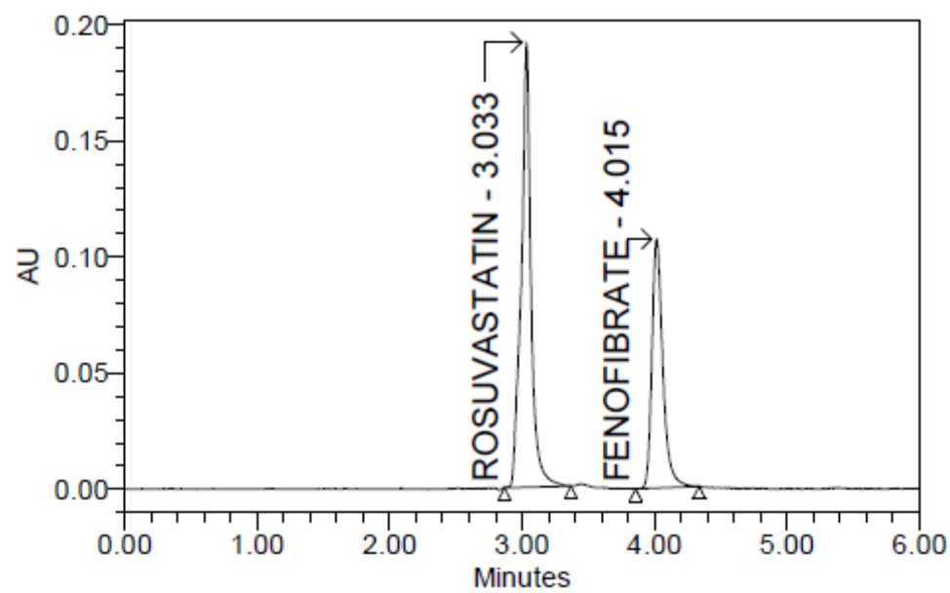
Fig 20: Chromatogram for precision injection 1
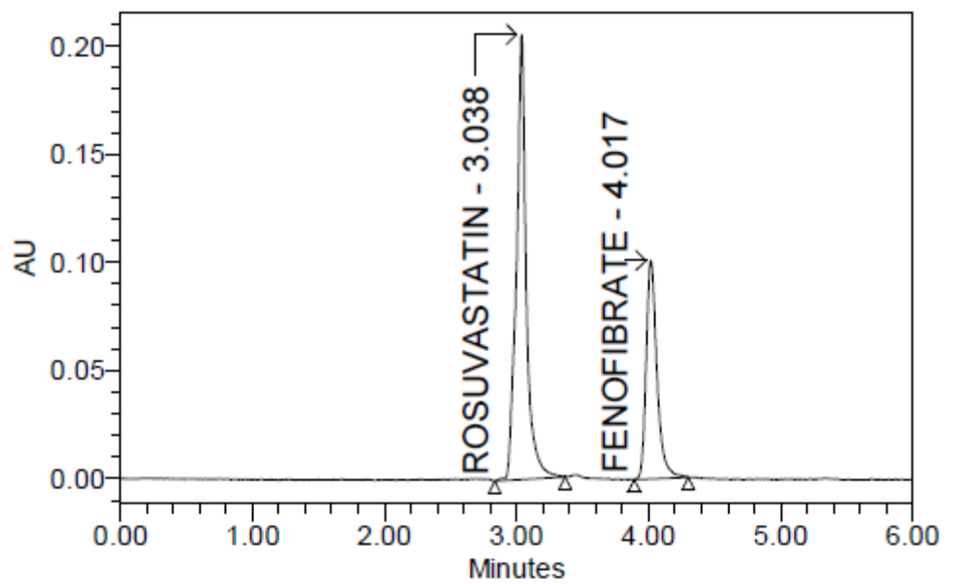
Fig 21: Chromatogram for precision injection 2
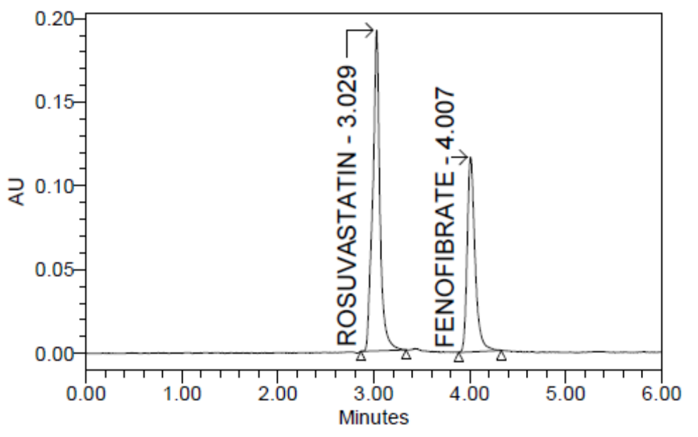
Fig 22: Chromatogram for precision injection 3
Fig 23: Chromatogram for precision injection 4
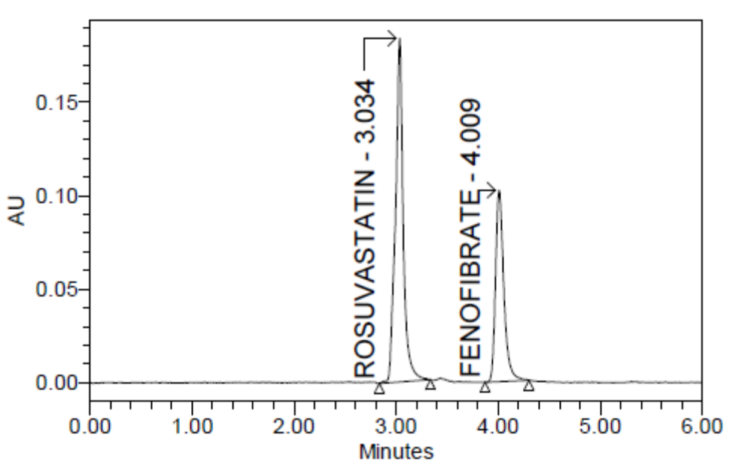
Fig 23: Chromatogram for precision injection 4
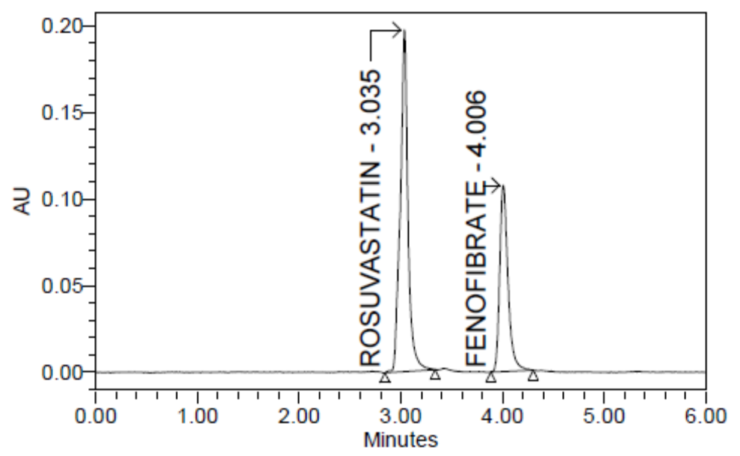
Fig 24: Chromatogram for precision injection 5
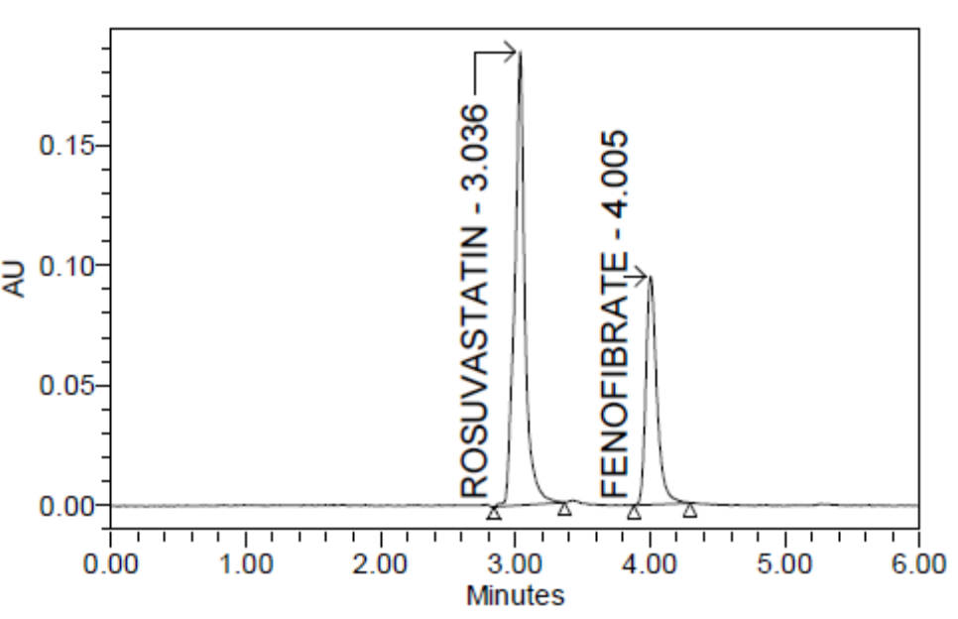
Fig 25: Chromatogram for precision injection 6

Table17: Precision data for Rosuvastatin

S.no | RT | Area | %Assay
injection1 | 3.033 | 987068 | 100
injection2 | 3.038 | 988906 | 100
injection3 | 3.029 | 984920 | 99
injection4 | 3.034 | 987281 | 100
injection5 | 3.035 | 983761 | 99
injection6 | 3.036 | 980357 | 99
Mean |  |  | 100
Std. Dev. |  |  | 0.31
% RSD |  |  | 0.31

Table 18: Precision data for Fenofibrate
S.no | RT | Area | %Assay
injection1 | 4.015 | 542102 | 99
injection 2 | 4.017 | 541359 | 99
injection 3 | 4.007 | 541707 | 99
injection 4 | 4.009 | 548226 | 100
injection 5 | 4.006 | 540612 | 98
injection 6 | 4.005 | 547875 | 100
Mean |  |  | 99
Std. Dev. |  |  | 0.63
%RSD |  |  | 0.63

Acceptance criteria:
- %RSD for sample should be NMT 2
- The %RSD for the standard solution is below 1, which is within the limits hence method is precise.
RESULT:
Results of variability were summarized in the above table. % RSD of peak areas was calculated for various run. Percentage relative standard deviation (%RSD) was found to be less than 2% which proves that method is precise.

7.5. LINEARITY:
Accurately weigh and transfer 430mg of Rosuvastatin and Fenofibrate into a 100 ml 0f clean dry volumetric flask and sonicate to dissolve it completely and make volume up to the mark with the same solvent.
(Stock Solution).
Further pipette 1ml of the above stock solution into a 10ml volumetric flask and dilute up to the mark with diluent.
Procedure:
Five different concentrations 50 μg, 75 μg, 100 μg,125 μg,150 μg were prepared and Inject each level into the chromatographic system and measure the peak area.
Plot a graph of peak area versus concentration (on X-axis concentration and on Y-axis Peak area) and calculate the correlation coefficient.
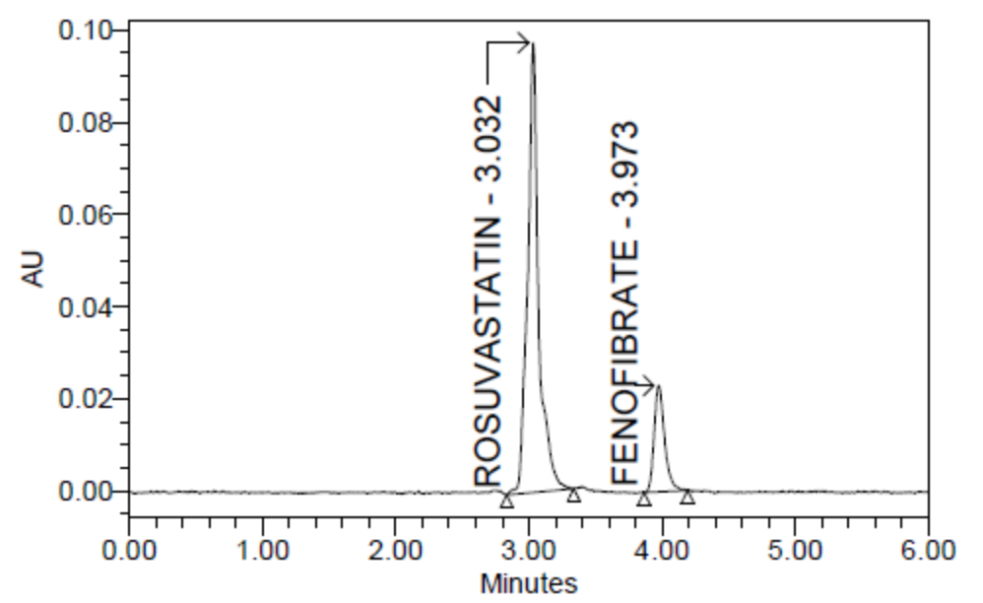
Fig 28: Chromatogram representing lineartity 1
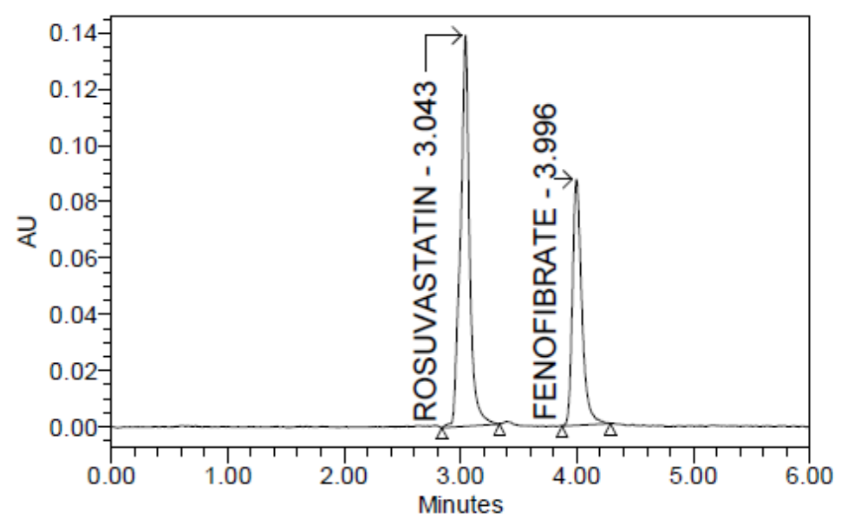
Fig 29: Chromatogram representing linearity 2
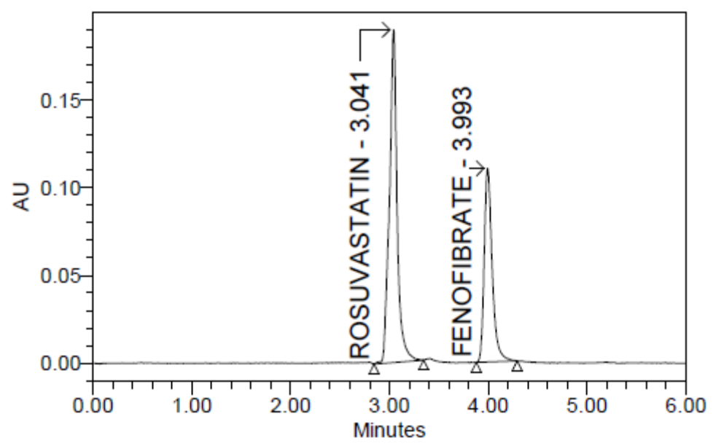
Fig 30:Chromatogram representing linearity 3
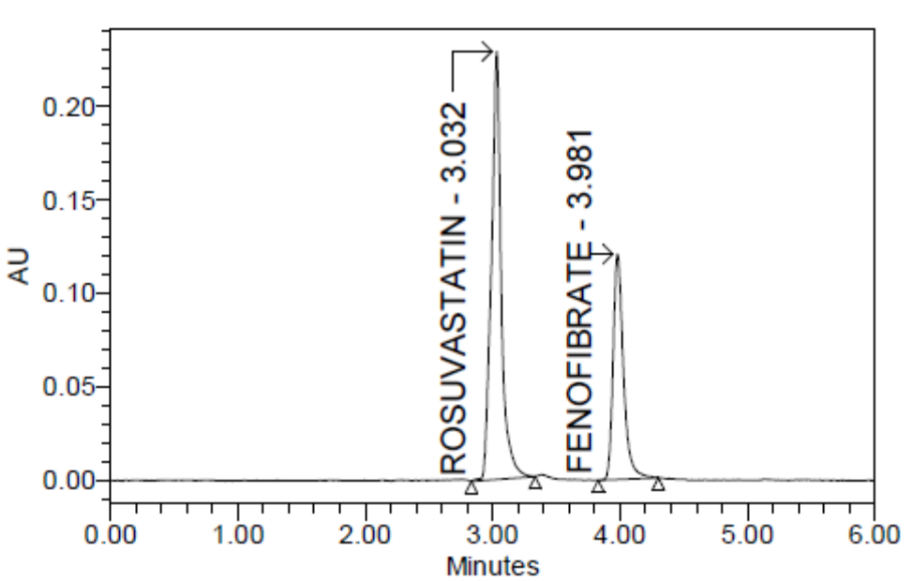
Fig 31: Chromatogram representing linearity 4
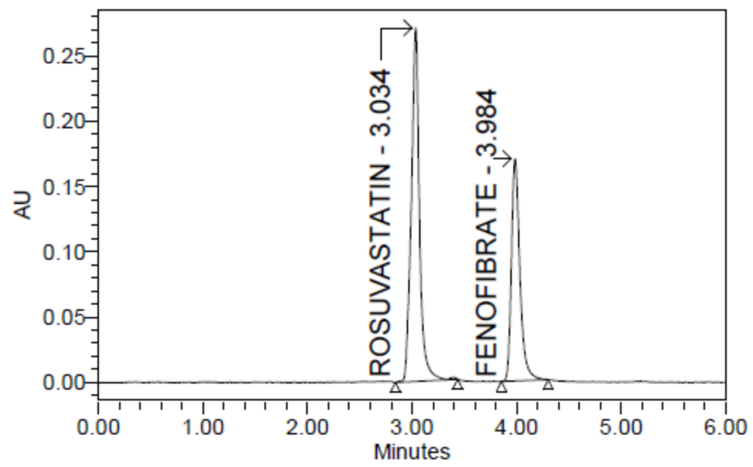
Fig 32: Chromatogram representing linearity 5

Table 19: Linearity data for Rosuvastatin
s.no | Conc (μg/ml) | RT | Area
1. | 50 | 3.032 | 498790
2. | 75 | 3.043 | 740243
3. | 100 | 3.041 | 982367
4. | 125 | 3.032 | 1232628
5. | 150 | 3.034 | 1481339
Correlation coefficient (r²) |  |  | 0.999

Fig 26: Linearity plot of Rosuvastatin
Table 20:Linearity data for Fenofibrate

s.no | Conc(μg/ml) | RT | Area
1. | 50 | 3.973 | 276329
2. | 75 | 3.996 | 407954
3. | 100 | 3.993 | 549937
4. | 125 | 3.981 | 680296
5. | 150 | 3.984 | 817736
Correlation coefficient (r²) |  |  | 0.999

Fig 27: Linearity plot of Fenofibrate

Acceptance criteria:
- Correlation coefficient (R²) should not be less than 0.999.
RESULT
A linear relationship between peak areas versus concentrations was observed for Rosuvastatin and Fenofibrate in the range of 50% to 150% of nominal concentration. Correlation coefficient was 0.999 for both Rosuvastatin and Fenofibrate which prove that the method is linear in the range of 50% to 150%.

7.6. ROBUSTNESS:
The standard and samples of Rosuvastatin and Fenofibrate were injected by changing the conditions of chromatography. There was no significant change in the parameters like resolution, tailing factor, asymmetric factor, and plate count.
As part of the Robustness, deliberate change in the Flow rate, Mobile Phase composition, Temperature Variation was made to evaluate the impact on the method.
Effect of variation in flow rate:
Prepare the system suitability solution as per the test method and inject into the HPLC system with ±0.2 ml of the method flow. Evaluate the system suitability values as required by the test method for both flow rates. Actual flow rate was 1.0 ml/min and it was changed to 0.8ml/min and 1.2ml/min and inject into HPLC and system suitability was checked.
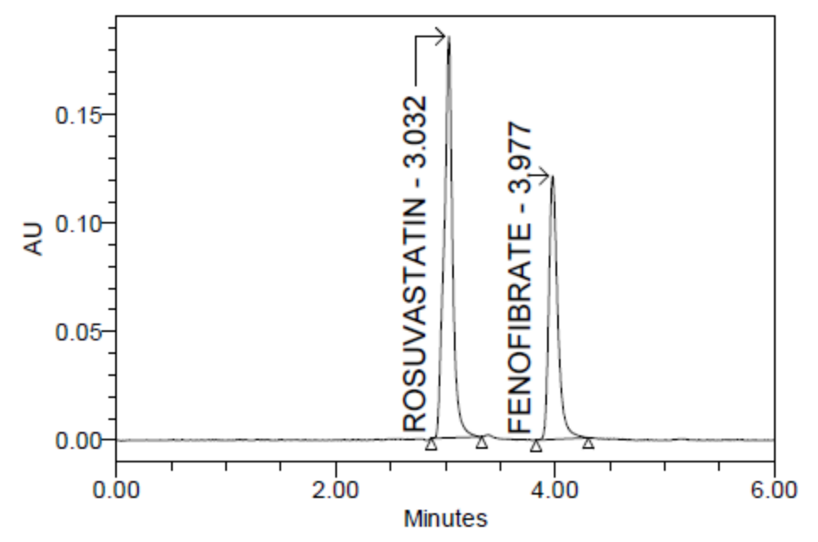

Fig 33: Chromatogram for decreased flow rate

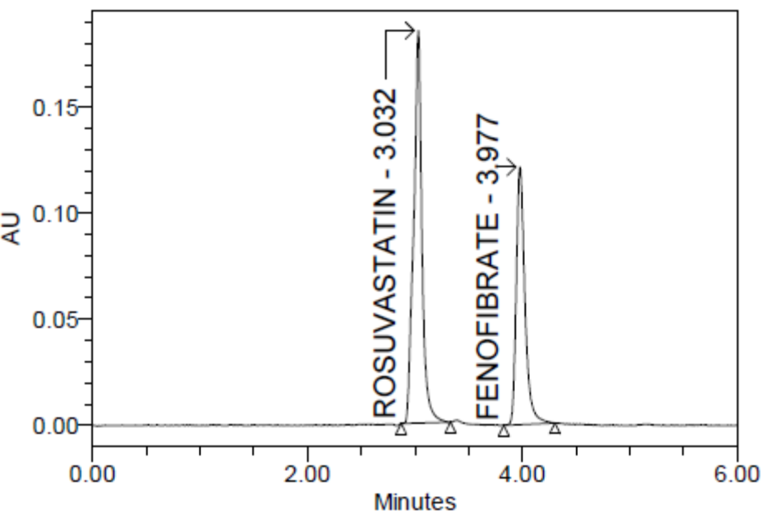
Fig 34: Chromatogram for increased flow rate
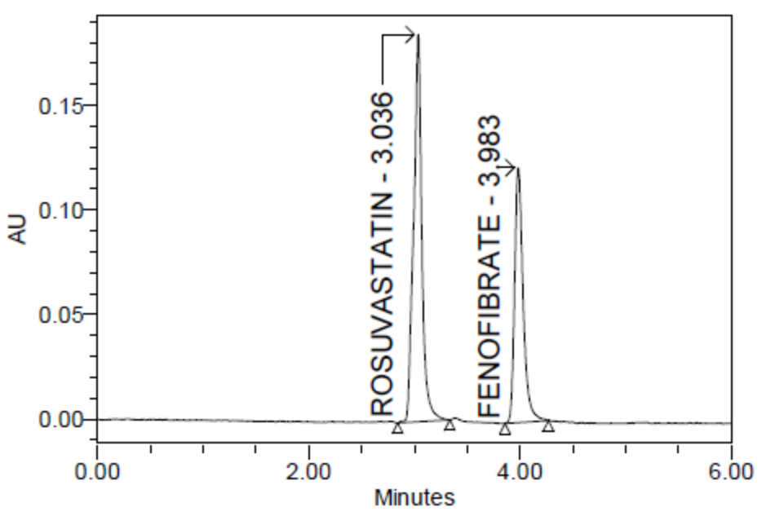
Fig 35: Chromatogram for decreased temperature
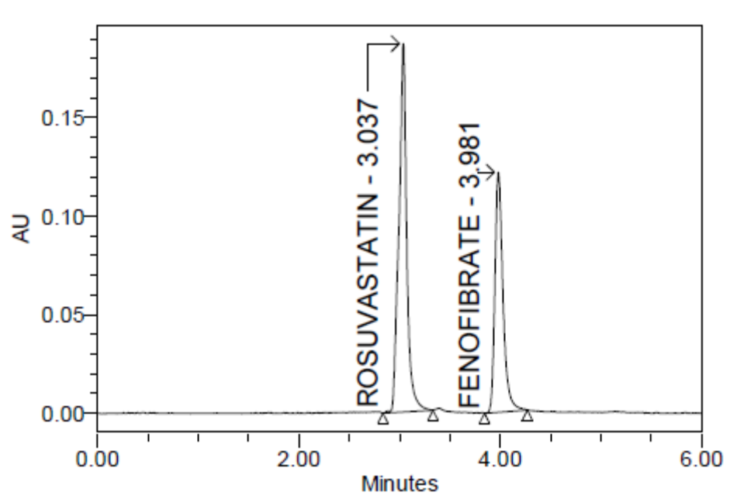
Fig 36: Chromatogram for increased temperature

Table 21: Robustness data for Rosuvastatin
parameter | RT | Theoretical plates | Tailing factor
Decreased flow rate(0.8ml/min) | 3.032 | 7366 | 1.02
Increased flow rate(1.2ml/min) | 3.031 | 7889 | 1.03
Decreased temperature(20⁰c) | 3.036 | 7044 | 1.03
Increased temperature(30⁰c) | 3.037 | 7254 | 1.03

Table 22 : Robustness data for Fenofibrate
parameter | RT | Theoretical plates | Tailing factors
Decreased flow rate (0.8ml/min) | 3.977 | 12760 | 1.36
Increased flow rate (1.2ml/min) | 3.977 | 12935 | 1.35
Decreased temperature(20⁰c) | 3.983 | 12833 | 1.35
Increased temperature(30⁰c) | 3.981 | 12897 | 1.34

RESULT
The results of Robustness of the present method had shown that changes made in the Flow and Temperature did not produce significant changes in analytical results which were presented in the above table. As the changes are not significant we can say that the method is Robust.

7.7. LIMIT OF DETCTION:
Minimum concentration of standard component in which the peak of the standard gets merged with noise called the LOD
LOD = 3.3* σ/S
Where;
σ = standard deviation
S = slope
LOD for Rosuvastatin = 3.040
LOD for Fenofibrate =3.985
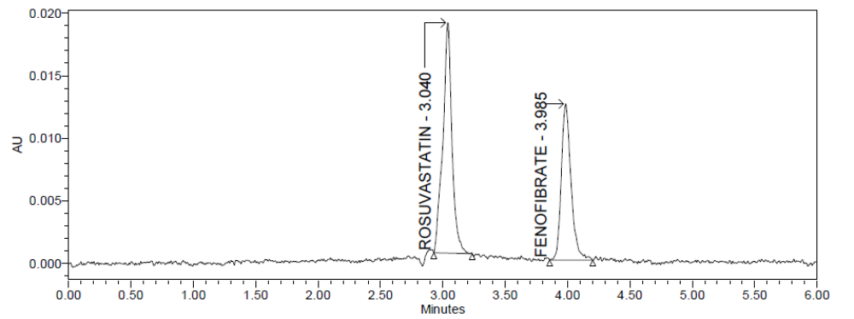

Fig 37: Chromatogram for LOD

LOD data for Rosuvastatin and Fenofibrate
s.no | Sample name | RT | Area
1 | Rosuvastatin | 3.040 | 93888
2 | Fenofibrate | 3.985 | 68054

7.8. LIMIT OF QUANTIFICATION:
Minimum concentration of standard component in which the peak of the standard gets detected and quantification
LOQ = 10*σ/S
Where;
σ = standard deviation
S = slope
LOQ for Rosuvastatin = 3.040
LOQ for Fenofibrate =3.984
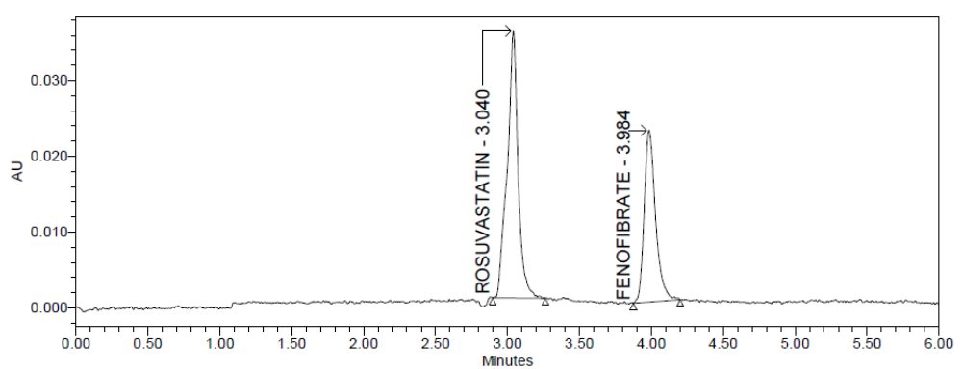
Fig 38: Chromatogram for LOQ
LOQ data for Rosuvastatin and Fenofibrate
S.no | Sample name | RT | Area
1 | Rosuvastatin | 3.040 | 185773
2 | Fenofibrate | 3.984 | 124485

